Byron Bay Surf Life Saving Club

How to create a family group and renew and pay membership fees for all members

You will need to complete the following 4 steps:

- LOG IN TO YOUR MEMBER’S AREA ACCOUNT (CREATE A MEMBER’S AREA ACCOUNT IF YOU DO NOT HAVE ONE)

- CREATE YOUR FAMILY GROUP (If you do not already have one)

- RENEW MEMBERSHIP FOR EACH FAMILY MEMBER

- PAY MEMBERSHIP FEES FOR ALL FAMILY MEMBERS

- LOG IN TO YOUR ACCOUNT /CREATE A MEMBER’S AREA ACCOUNT

Go to https://members.sls.com.au/SLSA_Online/modules/login/index.php

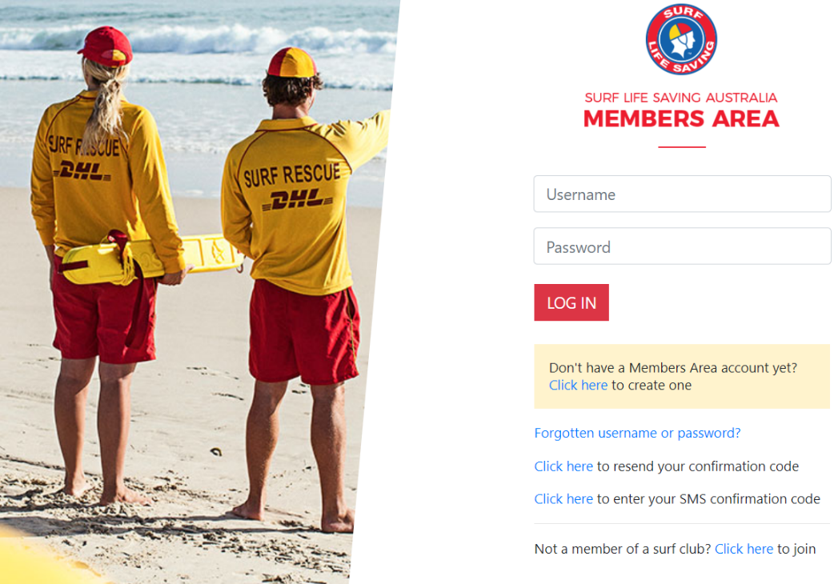

If you already have an account, log in.

If you don’t have a Members Area account, follow the link on the screen to create one.

To Create an Account, the system will try to match the details you provide with those stored for you in the database. If these are different, you will not be able to create an account.

Any problems, email registrar@byronbaysurfclub.org with your full name and date of birth.

Once you have an account, log in to the Members Area.

- CREATE YOUR FAMILY GROUP (If you do not already have one)

Click on the Memberships tab and then Family

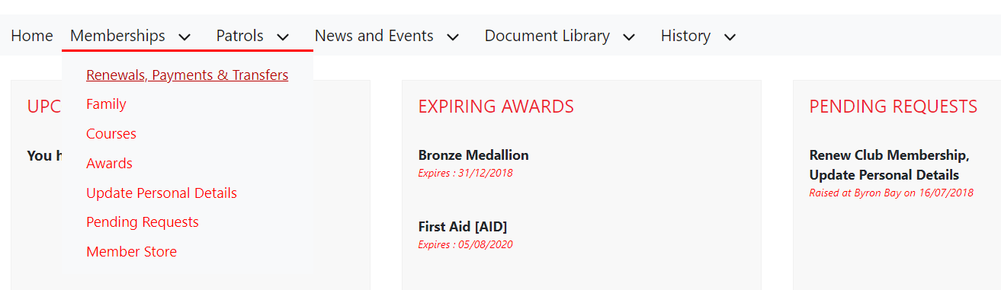

NEXT SCREEN: click on Create Family Group

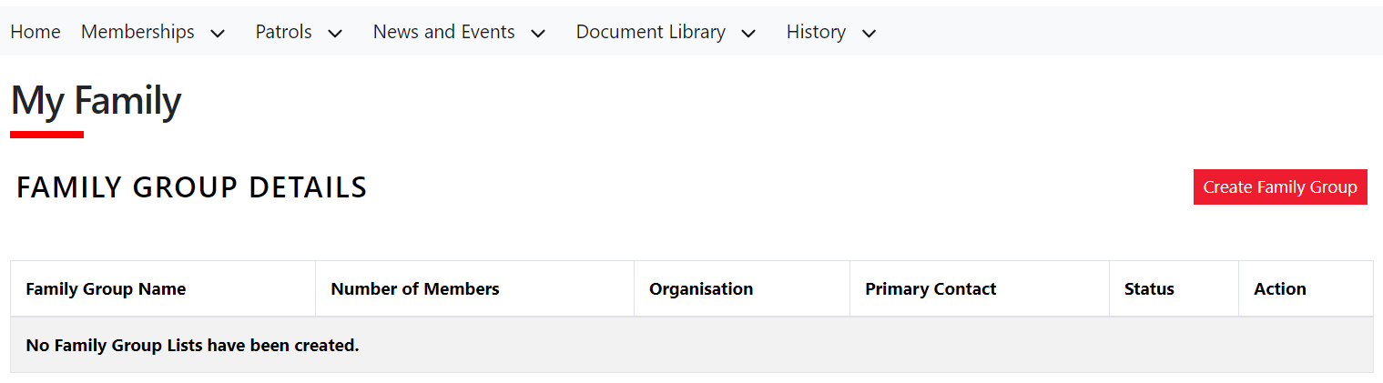

NEXT SCREEN:

Enter Family group name. (Suggest you use your Surname as your family group name)
Enter First Name, Last Name and Date of Birth for the first family member and click on Search.
The name of your first family member will appear in the Available Members section.

Continue entering details and searching until all family members are shown in the Available Members section. You do not need to search for yourself as you will automatically be a member of the group.

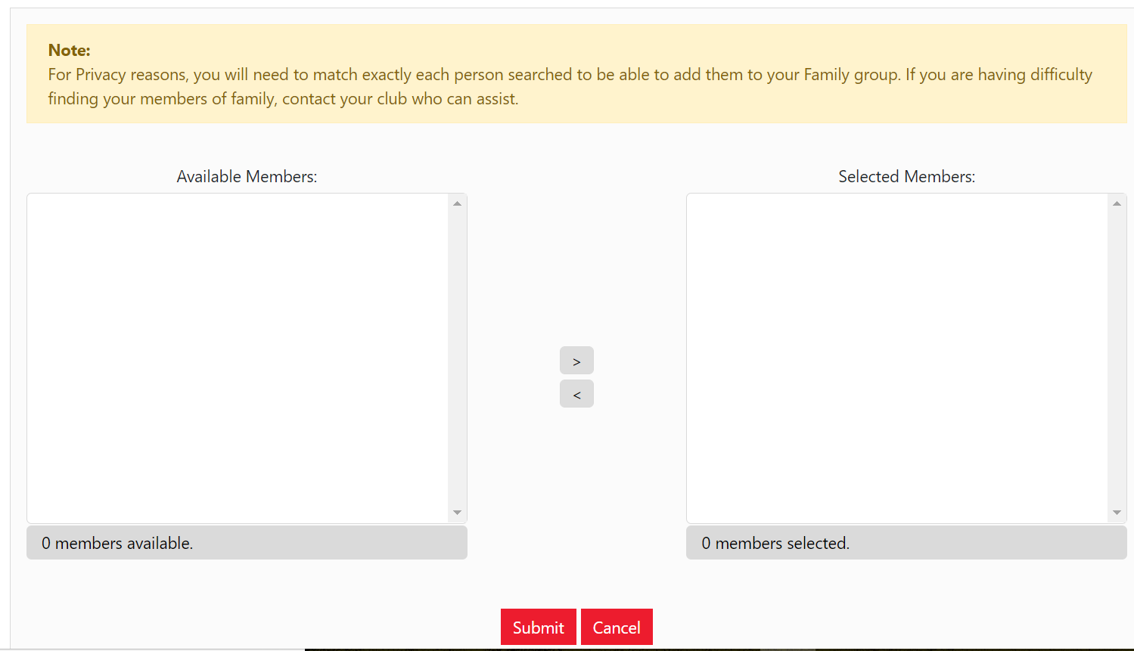

Click on each available family members’ name in the Available Members section and then click on the right arrow > to move each one across to the Selected Members section

When all family members are in the Selected Members section click on SUBMIT

NEXT SCREEN:

Confirms family group has been created.

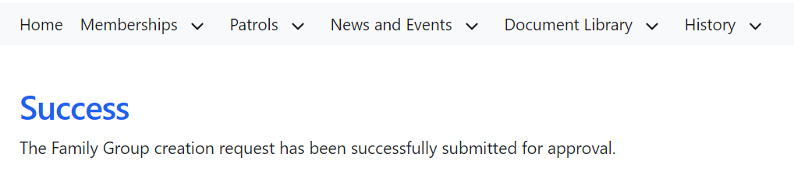

- RENEW MEMBERSHIP FOR EACH FAMILY MEMBER

Click on the Membership tab and then Family

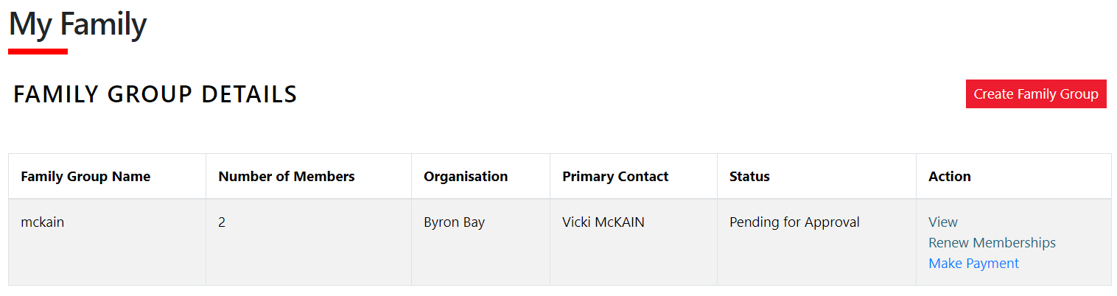

Click on Renew Memberships

The next screen will show all your family members.

You must TICK the box at the far left for EACH family member not just yourself.

TICK the box for SLSA Membership Declaration.

Click on Submit

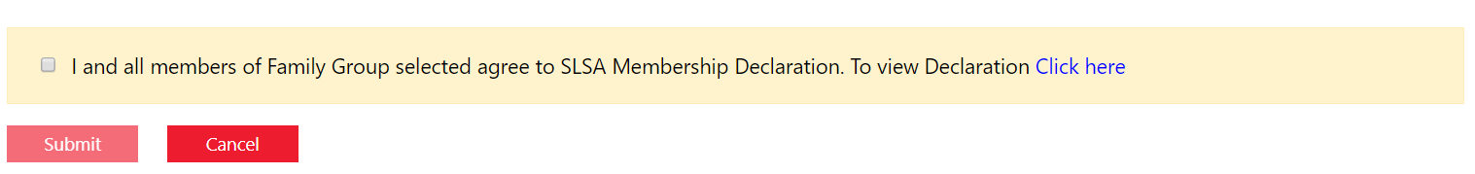

- PAY MEMBERSHIP FEES FOR ALL FAMILY MEMBERS

Click on the Membership tab and then Family

Click on Make Payment. You will be taken to the payment screen which also shows the fees for each membership type.

FOR SENIOR (+18yrs), JUNIOR (15-18yrs) and CADET (13-15yrs) MEMBERS:

For each family member, create a separate transaction.

Enter one family name (Surname and First Name) in the Payment Details and the corresponding membership fees in the Amount section. Click “Add another transaction” and enter the required information for the next family member. Repeat for all family members. The Total $ will show the sum of all fees to be paid.

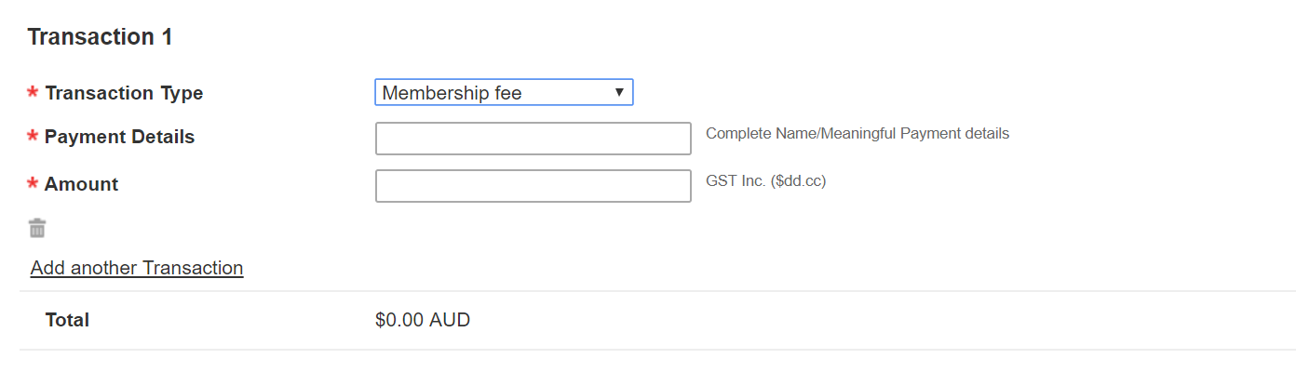
Click on NEXT

NEXT SCREEN, enter credit card details.

NEXT SCREEN, confirm payment.

NEXT SCREEN, you can print a payment receipt if you choose. You will also receive an email confirmation with the receipt.

The club will process your family members’ renewal applications only after you have completed BOTH the membership renewal process for EACH family member AND paid the membership fees.

