2019-2020 Function Room Info Pack
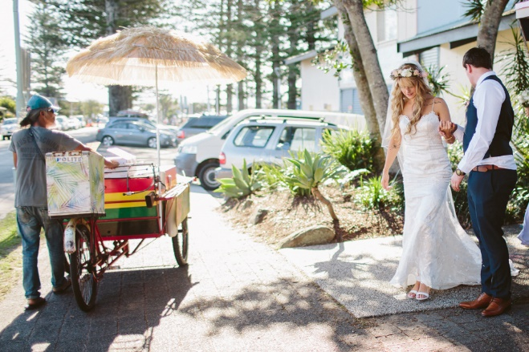

Welcome to Byron Bay Surf Life Saving Club

Located on the iconic Byron Bay foreshore and offering stunning views from the Light House to Mt Warning, our premier venue will provide breathtaking waterfront views for you and your guests and is the largest ocean front venue on the East coast of Australia.

Our unique venue offers supreme views on the most ‘sort after’ deck in prime location to enjoy your wedding ceremony on, followed by celebratory drinks at sunset with your reception and dance floor under the stars. The deck can be inter-joined to the surf clubs’ rustic & charming inside venue, so you may have the best of both worlds. Easily accommodating up to 150 seated with spectacular views the Surf Club is surpassed by none for beach front stunning wedding reception & function venues.

We have selected six of the finest chef’s & catering companies in Byron Bay for you to personally choose who will be your chef & team. Each of these companies boasts outstanding reputations & staff to manage every detail before & during your function. You will be able to select from their menu samples or request a quote on variation menu.
Supplying your own beverages for the bar staff to serve will allow you to select your favourite champagnes, wines etc at your favourite prices for your special occasion. Thank you for considering our venue for your function.

The following pages are for your information, however please fill in the last page and return it with your deposit to secure your date. Please note, Dates will be booked and confirmed with payment only. If you have any further enquiries email us at functions@byronbaysurfclub.org
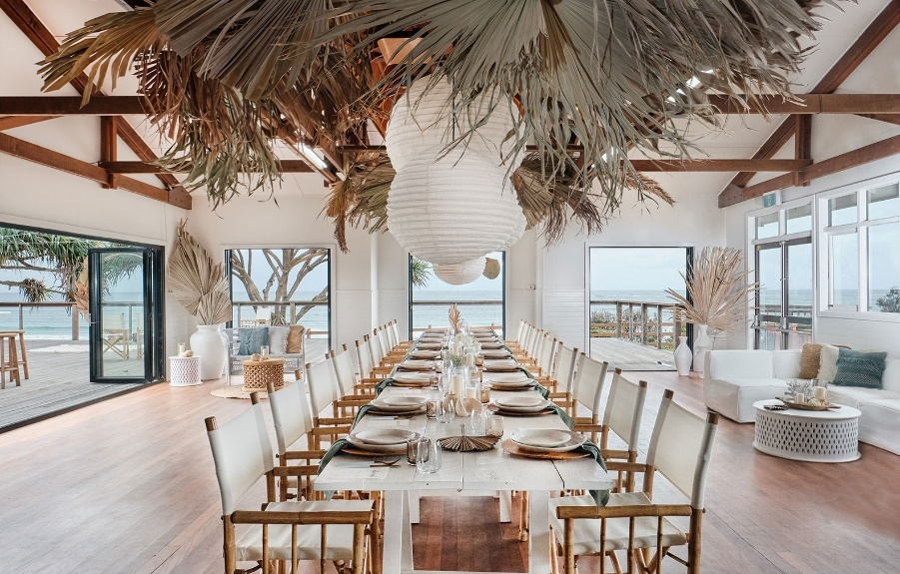

Hirers Information 2019-20
(Amended 09.09.2019)

COSTS:
For all Functions a $1000 bond/deposit is required in order to secure your date
All Weddings/ Functions $4500 Inc. GST

HALL ACCESS:
Friday Wedding - Access 8am-midnight. ACCESS through coordinator
Saturday Wedding - Access 8am-midnight. ACCESS through coordinator
If you require access the day before there is a $350 early entry Fee subject to availability. This can only be booked 4 weeks prior to event.

HIRE GOODS:
Must be collected on the night or with prior permission by 7-8am the following morning. This is dependent on future bookings of the space.

ALCOHOL:
All alcohol and glasses are the hirer’s responsibility. The surf club is fitted with a glass washer for your use.
Our preferred beverage partner is the BEACH HOTEL who offer exclusive discounts, FREE delivery and a full refund on any unused stock.
For enquiries please contact Damon or Greg at bottleshop@beachhotel.com.au or 0266856402. They will help customise your order to your needs and budget.

COORDINATER/CATERERS:
The surf club has a list of approved and preferred coordinators/caterers for you to choose from. These coordinators/ caterers meet current surf club requirements & restrictions. They cover a wide variety of styles and budgets; they are experienced in coordinating, catering and managing functions at the surf club. The surf club requires you select one of these coordinators/ caterers.
The coordinator/caterer you choose will be the overall manager of the function. They are responsible for access, basic set-up, catering, supervision, pack-down, clean and lock-up of the Surf Club.
All specialists engaged for your function - e.g. Celebrant, DJ – will need to liaise and work with your coordinator/caterer.

The Caterer/Function Managers that you can choose from are:
- Byron Bay Weddings
- Eat Drink Catering
- 100 Mile Table
- Friday Hut Dining
- The Larder
- Seaweed Cuisine
- Joe Chef Byron Bay Catering and Events
- Peachy Pie
- Frank and Joy
- Byron Wedding Vine
- Your Gourmet

Contact Details and links to each Caterer/Function managers website can be found on our website
https://byronbaysurfclub.org/caterers-managers/

DAMAGE/LOSS:
The Hirer will be responsible for and be required to make good any loss or damage to property, furniture or fittings. Such deductions will come from Bond monies plus other action may be initiated. Hirer is responsible for all other property brought onto the premises; hirer must insure his own property whilst on Club premises.
If furniture is dragged on wooden floor- it will scratch the floorboards. If furniture is not lifted, a minimum of $100 will be kept from the bond to pay for the floor to be sanded back and re-waxed.
FURNITURE:
Included in the hire cost is the use 150 white “wedding chairs”, 20 rectangular tables (2100x900) (no covers) and 16 round tables (1500) (no covers) - Rectangle seat 8-10. Round seat 8-9.
External furniture (e.g. cocktail furniture) may be used but must not have sharp edges on the legs and can cause damage to the floor. Please clarify with the coordinator.
The coordinator is responsible for packing furniture inside the hall after the function. The club is not liable for any theft of anything left on the outside deck after the function.
NOISE:
The hirer is subject to Noise Pollution Regulations and Police frequently issue on the spot tickets starting at $250 for infringements. Please consider the quiet and good order of the neighbourhood when leaving the premises.
Music must cease by: 11.00pm (No Exceptions)
KITCHEN:
The kitchen has the following inclusions and is to be left clean following the function
- Commercial Oven with 8 burner gas cook top
- 2 large stainless work benches
- 1 small stainless work bench (on wheels)
- Commercial Dishwasher
- Commercial Glass Washer
- Walk in cold room
- Regular standing fridge/freezer
- 2 Sinks
SUB LETTING: The Hirer is not to sub-let the premises.
DECORATIONS: Please ensure your stylist is aware of the following:
- No decorations will be fixed to any painted surface.
- No use of staples, nails, drawing pins or similar.
- No use of confetti or similar.
- No Candles unless enclosed in glass. No Sparklers
LIQUOR SALES:
A function license must be obtained 6 weeks prior to event from a Court if liquor is sold. Not needed if you are just providing alcohol, not selling.
HIRER:
Coordinator/Caterer must be on premises at all times and be responsible for the actions of any person/s on the premises whilst being hired. Caterer /Hirer is responsible for the security of property, premises, returning all property, keys etc. MAXIMUM CAPACITY – 150 PEOPLE.
INJURY:
Any member of the public, entertainer or employee injured on the premises shall be the responsibility of the hirer.
LIABILITY:
Byron Bay SLSC shall not be liable for loss, damage or injury to persons/ property whilst hirer is using these premises.
MARQUEE:
A marquee may be set up on the deck. Maximum size is 15x6m.
SECURITY:
The coordinator/caterer chosen from surf club list is required to lock up and secure all property.
PARKING:
Byron Bay SLSC is located on Crown Land and the Parks and Gardens are not the responsibility of Byron Bay SLSC.
Byron Shire Council advise that there is no parking allowed in the park adjacent to the hall. Drop-off and pick-up is allowed.
BOND PAYMENT:
This payment is required to hold ANY date in our calendar.
The Venue Bond is a set amount of $1000. It is to be paid by Direct Deposit ONLY.
If the contract is followed and the hall is left in the same condition, the full $1000 will be returned after you function. Please provide the account details on contract below so the $1000 can be deposited back to you.
VENUE FEE PAYMENT:
The venue fee for all weddings/ functions is $4500 and is due one month prior to your function. No access/keys to the surf club will be given until all payments have been made and finalized.
All Direct Deposit PAYMENTS are to be made into the following account
Account Name: Byron Bay Surf Lifesaving Club
BSB: 032 573
Account Number: 246485
Leave your surname and date of hire as reference e.g. smith01.01.18

CONDITIONS OF CLUB HOUSE HIRE: (Revised 22.09.2018)
Bond will be forfeited if any of the following are not adhered to:
- If the floor is scratched due to dragging of furniture.
- The Kitchen/Bar is not left clean and tidy with floor mopped.
- Stove inside and outside left clean.
- Hall floor must be vacuumed ONLY, at the end of the function.
- Tables and Chairs packed and returned to their original position.
- The Hirer must vacate any equipment at the end of the function.
- Bins provided are to be placed on the side of the road for collection, at the end of the function.
- Smoking is NOT ALLOWED on the premises
- A coordinator/caterer from the surf club list will be engaged to manage and caterer for your function.
- The surf club must be vacated by midnight.

This venue is one of the best value venues in Byron Bay. Please understand your requirements. Monies will be withheld if conditions are not adhered to.

Byron Bay SLSC is a non-profit volunteer organisation. We use funds raised from venue hire to assist in maintenance and repair of our club and for funding our surf and rescue services and equipment.
We would like to make special mention of the following conditions-
All weddings are required to select a surf club approved coordinator/caterer for your wedding at the surf club. They will manage, coordinate & cater for your wedding.
- The hall must be left as it was found with all floors vacuumed only, chairs & tables stacked back into storage as they were found, at the end of the night or function. - Done by approved coordinator.
- All furniture is to be carried (NOT DRAGGED) on the wooden floor.
- Premises are to be vacated by midnight - NO EXCEPTIPONS.
- The pack down & clean must be completed by coordinator/ caterer.
- Live music permitted, check current criteria - NO DRUMS or similar, & no more than three persons.
- No candles, sparklers or naked flames, unless enclosed in glass.
- No smoking in the hall or on deck. Smokers are to leave Surf Club premises.
- Bins are to be put out on the side of the road, the gutters edge, at the end of the night. They will be emptied at 4am for the next function.
If you have any further inquiries, please email functions@byronbaysurfclub.org

Regards Hall Hire Coordinator
On behalf of Byron Bay SLSC.

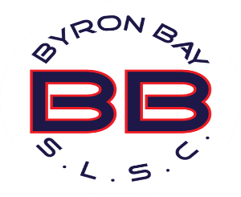
BYRON BAY SURF LIFE SAVING CLUB
CONTRACT FOR VENUE HIRE

DATE OF HIRE: _____________________________________________________

CONTACT NAME: _____________________________________________________

CONTACT PHONE: ______________________________________________

CONTACT EMAIL: ______________________________________________

ADDRESS: ______________________________________________

TYPE OF FUNCTION E.G. WEDDING/BIRTHDAY ETC

_____________________________________________________________________

NUMBER OF APPROX GUESTS: ________________________________________

GUEST ARRIVAL TIME: _____________________________________

APPROVED CATERER/COORDINATOR: _______________________________________

I have read and fully understand all the terms and conditions and agree to abide by them. If I breach any of these conditions, I understand that the agreement is forfeited forthwith.
Bond: $1000 Hiring Fee: $4500

SIGNED: ______________________________ DATE: ___________________

ACCOUNT FOR BOND REFUND:
Name: ___________________________________
BSB __________________ Account Number: __________________
SURF CLUB USE ONLY
Bond returned date: ______________________ Receipt Number: ___________________

