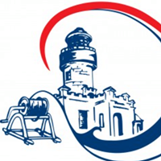
BYRON BAY SLSC
CLUB REOPENING & COVID-19 SAFETY 1/7/20 - COMPLY NSW GOVERNMENT

- Byron Bay SLSC is opening some areas and activities from 1/7/20
- We must adhere to NSW Health Guidelines
- If unwell - keep away from club and seek medical advice
- Practice physical distancing – 1.5m & allow 4m2 per person
- Use good personal hygiene
- Register when attending a group activity
- Do not gather in groups before or after activities
- Numbers of persons: Deck = 58, Hall = 58, Club Room = 20, Training Room = 18, Nipper Room = 12, Patrol Change = 5, Bathrooms = 7, Gym = 10, Outdoor training = 20
- Bathrooms and bathroom access areas are closed

