BBSLSC Wedding Function Room Hire
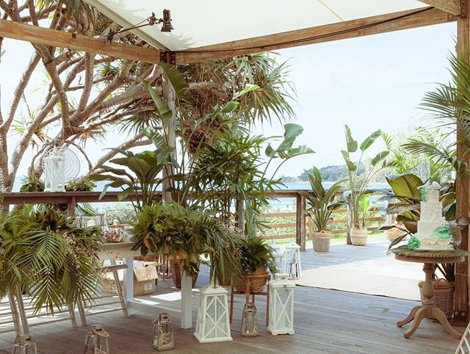

Welcome to Byron Bay Surf Life Saving Club
Located on the iconic Byron Bay foreshore and offering stunning views from the Light House to Mt Warning, our premier venue will provide breathtaking waterfront views for you and your guests and is the largest ocean front venue on the East coast of Australia.

Our unique venue offers supreme views on the most ‘sort after’ deck in prime location to enjoy your wedding ceremony on, followed by celebratory drinks at sunset with your reception and dance floor under the stars. The deck can be inter-joined to the surf clubs’ rustic & charming inside venue, so you may have the best of both worlds. Easily accommodating up to 150 seated with spectacular views the Surf Club is surpassed by none for beach front stunning wedding reception & function venues.

We have selected some of the finest chef’s & catering companies in Byron Bay for you to personally choose who will be your chef & team. Each of these companies boasts outstanding reputations & staff to manage every detail before & during your function. You will be able to select from their menu samples or request a quote on variation menu.
Supplying your own beverages for the bar staff to serve will allow you to select your favourite champagnes, wines etc at your favourite prices for your special occasion. Thank you for considering our venue for your function.

The following pages are for your information, however, please fill in the last page and return it with your deposit to secure your date. Please note, Dates will be booked and confirmed with payment only. If you have any further enquiries email us at functions@byronbaysurfclub.org
Hirers Information 2024
(Amended 03.02.2023)

COSTS:
For all Functions, a $1000 deposit is required to secure your date. This is then held as a BOND.
All Weddings/ Functions then require further payment of $6000 Inc. GST 12 weeks before the event.

HALL ACCESS:
Friday Wedding - Access 8am-midnight. ACCESS through coordinator
Saturday Wedding - Access 8am-midnight. ACCESS through coordinator

HIRE GOODS:
Must be collected on the night or with prior permission by 8am the following morning. This is dependent on future bookings of the space.

ALCOHOL:
All alcohol and glasses are the hirer’s responsibility. The surf club is fitted with a glass washer for your use.
Our preferred beverage partner is the BEACH HOTEL who offer exclusive discounts, FREE delivery, and a full refund on any unused stock.
For enquiries, please contact bottleshop@beachhotel.com.au or 0266856402. They will help customise your order to your needs and budget.
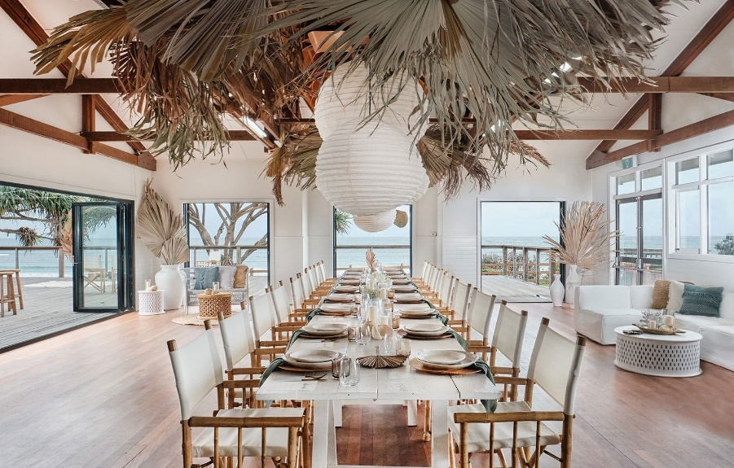

COORDINATER/CATERERS:
The surf club has a list of approved and preferred coordinators/caterers for you to choose from. These coordinators/ caterers meet current surf club requirements & restrictions. They cover a wide variety of styles and budgets; they are experienced in coordinating, catering, and managing functions at the surf club. The surf club requires you select one of these coordinators/ caterers.
The coordinator/caterer you choose will be the overall manager of the function. They are responsible for access, basic set-up, catering, supervision, pack-down, clean and lock-up of the Surf Club.
All specialists engaged for your function - e.g., Celebrant, DJ – will need to liaise and work with your coordinator/caterer.

The Caterer/Function Managers that you can choose from are:
- Byron Bay Weddings
- Eat Drink Catering
- The Larder
- Seaweed Cuisine
- Hungry Like the Wolf
- Your Gourmet
- Joe Chef Byron Bay Catering and Events
- Peachy Pie
- Frank and Joy
- Byron Wedding Vine
- Creative Weddings Byron Bay
- Savvy Weddings
- Whizbang Events

Contact Details and links to each Caterer/Function managers website can be found on our website
https://byronbaysurfclub.org/function-room/

DAMAGE/LOSS:
The Hirer will be responsible for and be required to make good any loss or damage to property, furniture, or fittings. Such deductions will come from Bond monies plus other action may be initiated. Hirer is responsible for all other property brought onto the premises; hirer must insure his own property whilst on Club premises.
If furniture is dragged on wooden floor- it will scratch the floorboards. If furniture is not lifted and obvious drag marks have been left, a minimum of $100 will be kept from the bond to pay for the floor to be sanded back and re-waxed.
Any vomit found in toilets after the event will incur a $100 deduction from bond per cubical/urinal for cleaning.

FURNITURE:
Included in the hire cost is the use 150 white “wedding chairs”, 20 rectangular tables (2100x900) (no covers) and 16 round tables (1500) (no covers) - Rectangle seat 8-10. Round seat 8-9.
External furniture (e.g., cocktail furniture) may be used but must not have sharp edges on the legs and can cause damage to the floor. Please clarify with the coordinator.
The coordinator is responsible for packing furniture inside the hall after the function. The club is not liable for any theft of anything left on the outside deck after the function.
NOISE:
The hirer is subject to Noise Pollution Regulations and Police frequently issue on the spot tickets starting at $250 for infringements. Please consider the quiet and good order of the neighbourhood when leaving the premises.
Music must not reach louder than 80 Dbs. or you will be in breach of your contract and will risk losing your bond.
Music must cease by 11.00pm (No Exceptions)
KITCHEN:
The kitchen has the following inclusions and is to be left clean following the function.
- Commercial Oven with 8 burner gas cook tops
- 2 large stainless work benches
- 1 small stainless work bench (on wheels)
- Commercial Dishwasher
- Commercial Glass Washer
- Walk in cold room.
- Regular standing fridge/freezer
- 2 Sinks
SUB LETTING: The Hirer is not to sub-let the premises.

DECORATIONS: Please ensure your stylist is aware of the following:
- No decorations will be fixed to any painted surface.
- No use of staples, nails, drawing pins or similar.
- No use of confetti or similar.
- No Candles unless enclosed in glass. No Sparklers
LIQUOR SALES:
A function license must be obtained 6 weeks prior to event from a Court if liquor is sold. Not needed if you are just providing alcohol, not selling.
HIRER:
Coordinator/Caterer must always be on premises and be responsible for the actions of any person/s on the premises whilst being hired. Caterer /Hirer is responsible for the security of property, premises, returning all property, keys etc. MAXIMUM CAPACITY – 150 PEOPLE.
INJURY:
Any member of the public, entertainer or employee injured on the premises shall be the responsibility of the hirer.
LIABILITY:
Byron Bay SLSC shall not be liable for loss, damage, or injury to persons/ property whilst hirer is using these premises.
MARQUEE:
A marquee may be set up on the deck. Maximum size is 15x6m.
SECURITY:
The coordinator/caterer chosen from surf club list is required to lock up and secure all property.
PARKING:
Byron Bay SLSC is located on Crown Land and the Parks and Gardens are not the responsibility of Byron Bay SLSC.
Byron Shire Council advise that there is no parking allowed in the park adjacent to the hall. Drop-off and pick-up is allowed.
BOND PAYMENT:
This payment is required to hold ANY date in our calendar.
The Venue Bond is a set amount of $1000. It is to be paid by Direct Deposit ONLY.
If the contract is followed and the hall is left in the same condition, the full $1000 will be returned after you function. Please provide the account details on contract below so the $1000 can be deposited back to you. All bonds are returned in the first week of the following month after the event.
REFUND POLICY:
Cancellations within 12 MONTHS OF THE EVENT will forfeit the deposit and any other monies paid and no refunds will be issued.
VENUE FEE PAYMENT:
The venue fee for all weddings/ functions is $6000 and is due 12 weeks prior to your function. No access/keys to the surf club will be given until all payments have been made and finalized.

All Direct Deposit PAYMENTS are to be made into the following account.
Account Name: Byron Bay Surf Lifesaving Club
BSB: 032 573
Account Number: 246485
Leave surname and date of hire as reference e.g., smith01.01.18

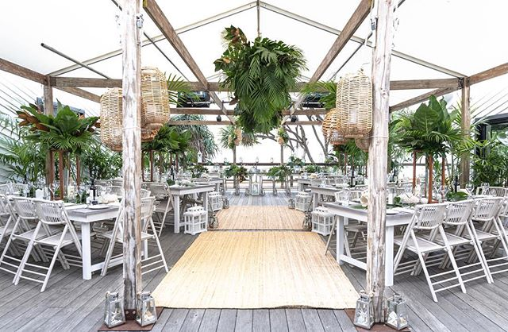
Byron Bay Surf Lifesaving Club Terms and Conditions for Function Room Hire
CONDITIONS OF CLUB HOUSE HIRE REVISED 03/2021
PLEASE READ THE FOLLOWING TERMS AND CONDITIONS CAREFULLY.
Bond will be forfeited if any of the following are not adhered to-:
By your chosen Caterer/ coordinator or guests
• If the floor is scratched due to dragging of furniture.
• The Kitchen/Bar is left clean and tidy with floor mopped.
• Stove inside and outside must be left clean.
• Hall floor must be vacuumed or swept at the end of the function.
• Tables and Chairs packed and returned to their original position.
• All decorations including floral arrangements must be removed.
• No candles, sparklers or naked flames unless enclosed in glass.
• Maximum of 3-piece band, ABSOLUTELY No Drums or Wind Instruments permitted.
• Smoking is NOT ALLOWED on the premises including at the front of the club. Please make sure smokers are on the grass area on the Eastern side near the bins that have smokers’ ashtrays.
• A coordinator/caterer from the Surf Club list will be engaged to manage and cater for your function. All wait staff serving Alcohol must have a current RSA
• All music must cease at 11PM and guests must also be off the premises by 11.30PM. The surf club must be vacated and locked by midnight. NO EXCEPTIONS
• Music must not exceed 80dbls or you will risk losing your Bond. This will be monitored by your caterer and the club’s caretaker. 3 warnings are instant loss of Bond.
• Bins must be put on the road for collection that evening.
• Entry is from 8am the day of the event and all suppliers must pick up gear by 8am the next day at the very latest.
• No parking on grass area adjacent to club. This is a drop off/pick up area only and includes KOMBI Van style Photo Booths or Food trucks.

Cancellation Policy
Cancellations within 12 MONTHS OF THE EVENT will forfeit the deposit and any other monies paid and no refunds will be issued.
In case of COVID restrictions all deposits are transferrable to another date. If wedding is cancelled and you choose not to transfer your deposit to another date at our venue the deposit is nonrefundable, but all other monies paid will be refunded.

Byron Bay SLSC is a non-profit volunteer organisation. We use funds raised from venue hire to assist in maintenance and repair of our club and for funding our surf and rescue services and equipment.
Please ensure you understand your requirements. Monies will be withheld if the contract is not strictly adhered to.

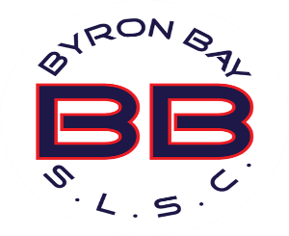
BYRON BAY SURF LIFE SAVING CLUB
CONTRACT FOR VENUE HIRE

DATE OF HIRE: _____________________________________________________

CONTACT NAME: _____________________________________________________

CONTACT PHONE: ______________________________________________

CONTACT EMAIL: ______________________________________________

ADDRESS: ______________________________________________

TYPE OF FUNCTION E.G. WEDDING/BIRTHDAY ETC

_____________________________________________________________________

NUMBER OF APPROX GUESTS: ________________________________________

GUEST ARRIVAL TIME: _____________________________________

APPROVED CATERER/COORDINATOR: _______________________________________

I have read and fully understand all the terms and conditions and agree to abide by them. If I breach any of these conditions, I understand that the agreement is forfeited forthwith.
Bond: $1000 Hiring Fee: $6000

SIGNED: ______________________________ DATE: ___________________

ACCOUNT FOR BOND REFUND:
Name: ___________________________________
BSB __________________ Account Number: __________________
SURF CLUB USE ONLY
Bond returned date: ______________________ Receipt Number: ___________________

NOTES

2020 Function Room Info Pack

